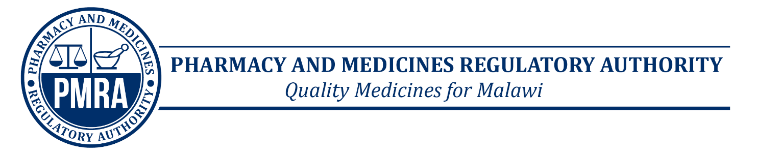
FORM 8 ADVT

APPLICATION FOR ADVERTISEMENT OF MEDICINE OR ALLIED SUBSTANCE
1. Particulars of Applicant:
(1) Name of applicant ………………………………...………………………………………………….
(2) Physical address/location………………………………………………………………………...
(3) Postal address …………………………………………………………………………………………
……………………………………………………………………………………………………………….
(4) E-mail address……………………………………………………………………………………….
(5) Full name and title of signatory…………………………………………………………………
……………………………………………………………………………………………………………….
2. Description of Advertisement:
(1) Type of activity (ies) for which application is made
(Example launch, advertisement, talk-show, exhibition,)
…………..…..…………………………………………………………………….
(2) Type of material (s) to be used (Attach 2 samples)
(Example: posters, literature, bags, calendars, audio, video)
……………………………………………………………….……………………
(3) Medicine or allied substance name …………………………………….……………………..
(4) Language of the publication or advert…………………….…..……………………………..
(6) Intended target group
(Example: Healthcare professionals, general public)
……………………………………………………………………………….
(5) Date of application…………………………….… Signature …………………………

3. For Official Use Only
(1) Fees payable………………………………………..
(2) Receipt No………….………………………………. Date……………………………………
(3) PMRA entry No…………………………………………….
(4) Application and samples received by (name)……………………………………………..
Signature…………………………………. Date…………………………………

